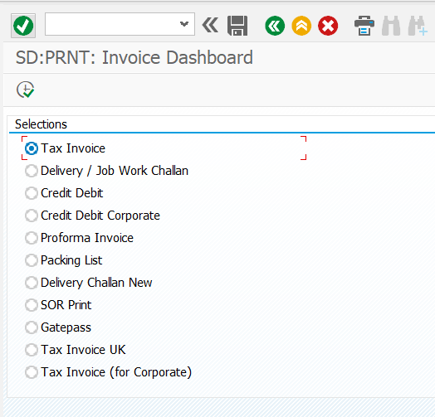

REPORT zsdep_form_dashboard.
SELECTION-SCREEN: BEGIN OF BLOCK a1 WITH FRAME TITLE TEXT-001.
PARAMETERS : rad_tax TYPE char01 RADIOBUTTON GROUP g1 DEFAULT 'X' USER-COMMAND rad,
rad_del TYPE char01 RADIOBUTTON GROUP g1,
rad_dc TYPE char01 RADIOBUTTON GROUP g1,
rad_p9 TYPE char01 RADIOBUTTON GROUP g1,
rad_pi TYPE char01 RADIOBUTTON GROUP g1,
rad_pl TYPE char01 RADIOBUTTON GROUP g1,
rad_p2 TYPE char01 RADIOBUTTON GROUP g1,
rad_p3 TYPE char01 RADIOBUTTON GROUP g1,
rad_gp TYPE char01 RADIOBUTTON GROUP g1,
p_r6 TYPE char01 RADIOBUTTON GROUP g1, " radio button for UK
p_r7 TYPE char01 RADIOBUTTON GROUP g1. "radio button for Corporate
SELECTION-SCREEN: END OF BLOCK a1.
IF rad_tax EQ abap_true.
SUBMIT zsdep_tax_invoice VIA SELECTION-SCREEN AND RETURN. "#EC CI_SUBMIT
ELSEIF rad_del EQ abap_true.
SUBMIT zsdep_delivery_challan VIA SELECTION-SCREEN AND RETURN. "#EC CI_SUBMIT
ELSEIF rad_dc EQ abap_true.
SUBMIT zsdep_inv_credit_debit_note VIA SELECTION-SCREEN AND RETURN. "#EC CI_SUBMIT
ELSEIF rad_p9 EQ abap_true.
SUBMIT zsdep_inv_cred_debit_corp VIA SELECTION-SCREEN AND RETURN. "#EC CI_SUBMIT
ELSEIF rad_pi EQ abap_true.
SUBMIT zsdep_proforma_invoice VIA SELECTION-SCREEN AND RETURN. "#EC CI_SUBMIT
ELSEIF rad_pl EQ abap_true.
SUBMIT zsdep_packing_list VIA SELECTION-SCREEN AND RETURN. "#EC CI_SUBMIT
ELSEIF rad_p2 EQ abap_true.
SUBMIT zsdep_delivery_challan_new VIA SELECTION-SCREEN AND RETURN. "#EC CI_SUBMIT
ELSEIF rad_p3 EQ abap_true.
SUBMIT zsdep_sales_order_print VIA SELECTION-SCREEN AND RETURN. "#EC CI_SUBMIT
ELSEIF rad_gp EQ abap_true.
SUBMIT zsdep_gatepass VIA SELECTION-SCREEN AND RETURN. "#EC CI_SUBMIT
ELSEIF p_r6 EQ abap_true.
SUBMIT zsdep_taxinv_uk VIA SELECTION-SCREEN AND RETURN. "#EC CI_SUBMIT
ELSEIF p_r7 EQ abap_true.
SUBMIT zsdep_tax_invoice_corp VIA SELECTION-SCREEN AND RETURN. "#EC CI_SUBMIT
ENDIF.

